**ASSIGNMENT 10.3**

**TEMPERATURE DATASET**

10-01-1990,123112,10

14-02-1991,283901,11

10-03-1990,381920,15

10-01-1991,302918,22

12-02-1990,384902,9

10-01-1991,123112,11

14-02-1990,283901,12

10-03-1991,381920,16

10-01-1990,302918,23

12-02-1991,384902,10

10-01-1993,123112,11

14-02-1994,283901,12

10-03-1993,381920,16

10-01-1994,302918,23

12-02-1991,384902,10

10-01-1991,123112,11

14-02-1990,283901,12

10-03-1991,381920,16

10-01-1990,302918,23

12-02-1991,384902,10

**QUERY 1**

Fetch date and temperature from temperature_data where zip code is greater than 300000 and less than 399999.

SELECT date,temperature from temperature_data where zip_code>300000 AND zip_code<399999;

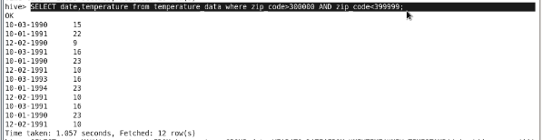

**QUERY 2**

Calculate maximum temperature corresponding to every year from temperature_data table.

SELECT YEAR(FROM_UNIXTIME(UNIX_TIMESTAMP(date,'dd-mm-yyyy'))) as date, MAX(temperature) as max_temp FROM temperature_data GROUP BY YEAR(FROM_UNIXTIME(UNIX_TIMESTAMP(date,'dd-mm-yyyy')));

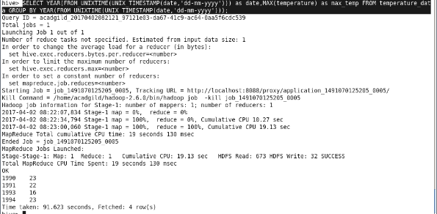

**QUERY 3**

Calculate maximum temperature from temperature_data table corresponding to those years which have at least 2 entries in the table.

SELECT YEAR(FROM_UNIXTIME(UNIX_TIMESTAMP(date,'dd-mm-yyyy'))) as date, MAX(temperature) as max_temp FROM temperature_data GROUP BY YEAR(FROM_UNIXTIME(UNIX_TIMESTAMP(date,'dd-mm-yyyy'))) HAVING COUNT(date)>=2;

